Under finner du en rekke eksempeler i bruk av Node-Red i våre ADAM-6700 IIoT kontrollere.
Eksemplene kan enkelt kopieres direkte inn i Node-Red.
Dette er ment som en inspirasjon på hvordan man enkelt kan bruke ADAM-67xx serien til store ting.

Innhold
Modbus RTU 2
Modbus TCP 3
REST API mot WISE-4220 4
Ta imot P2P data fra ADAM-6000/6200 moduler 5
Ta imot Stream data fra ADAM-6000/6200 moduler 6
Link opp mot WebOP Designer - WebAccessHMI 7
Klokke og dato 8
Bruke dashboard template til å lage egne web objekter 9
Simple Moving averages SMA 10
Kombinere innganger til en melding [objekter] 11

Modbus RTU
Eksempel med henting av data fra en ADAM-4015 Analog inngang med Modbus RTU protokollen.
Data vises gjennom WEN grensesnitt
ADAM-4015 konfigurasjon
Adresse 01
Tilkoblet ADAM-67XX på COM1 (/dev/ttyAP0)

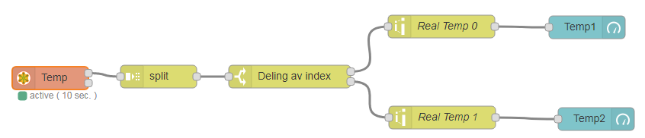
Flow:
[{"id":"2e0d0bb1.6810a4","type":"modbus-read","z":"6ad15031.90327","name":"Temp","showStatusActivities":false,"showErrors":false,"unitid":"1","dataType":"HoldingRegister","adr":"4","quantity":"2","rate":"10","rateUnit":"s","server":"810105c3.ad5688","x":120,"y":196,"wires":[["93ec9c77.495b2"],[]]},{"id":"93ec9c77.495b2","type":"split","z":"6ad15031.90327","name":"","splt":"\\n","spltType":"str","arraySplt":1,"arraySpltType":"len","stream":false,"addname":"","x":262,"y":194,"wires":[["2490be1b.31d1d2"]]},{"id":"2490be1b.31d1d2","type":"switch","z":"6ad15031.90327","name":"Deling av index","property":"msg.parts.index","propertyType":"msg","rules":[{"t":"eq","v":"0","vt":"str"},{"t":"eq","v":"1","vt":"str"}],"checkall":"true","outputs":2,"x":434,"y":194,"wires":[["bfa181a5.798b3"],["f9857c0d.90e13"]]},{"id":"87c9eca6.9c982","type":"ui_gauge","z":"6ad15031.90327","name":"Temp1","group":"b6670e72.d35c8","order":1,"width":0,"height":0,"gtype":"donut","title":"Temp1","label":"ºC","format":"{{value | number:1}}","min":0,"max":"60","colors":["#00b500","#e6e600","#ca3838"],"seg1":"","seg2":"","x":824,"y":129,"wires":[]},{"id":"bfa181a5.798b3","type":"range","z":"6ad15031.90327","minin":"0","maxin":"65535","minout":"0","maxout":"100","action":"scale","round":true,"name":"Real Temp 0","x":633,"y":128,"wires":[["87c9eca6.9c982"]]},{"id":"f9857c0d.90e13","type":"range","z":"6ad15031.90327","minin":"0","maxin":"65535","minout":"0","maxout":"100","action":"scale","round":true,"name":"Real Temp 1","x":634,"y":248,"wires":[["37cbfa95.fb6e36"]]},{"id":"37cbfa95.fb6e36","type":"ui_gauge","z":"6ad15031.90327","name":"Temp2","group":"b6670e72.d35c8","order":1,"width":0,"height":0,"gtype":"gage","title":"Temp2","label":"ºC","format":"{{value | number:1}}","min":0,"max":"40","colors":["#00b500","#e6e600","#ca3838"],"seg1":"","seg2":"","x":836,"y":250,"wires":[]},{"id":"810105c3.ad5688","type":"modbus-client","z":"","name":"ADAM4015","clienttype":"simpleser","bufferCommands":true,"stateLogEnabled":false,"tcpHost":"127.0.0.1","tcpPort":"502","tcpType":"DEFAULT","serialPort":"COM1","serialType":"RTU","serialBaudrate":"9600","serialDatabits":"8","serialStopbits":"1","serialParity":"none","serialConnectionDelay":"100","unit_id":1,"commandDelay":1,"clientTimeout":1000,"reconnectTimeout":2000},{"id":"b6670e72.d35c8","type":"ui_group","z":"","name":"ModbusRTU","tab":"1c04fb23.e45705","disp":true,"width":"6"},{"id":"1c04fb23.e45705","type":"ui_tab","z":"","name":"ModbusRTU","icon":"dashboard"}]

Modbus TCP
Eksempel med henting av temp og fukt data fra en WISE-4220 Analog inngang med Modbus TCP protokollen. Visniag av data på et WEB grensesnitt.
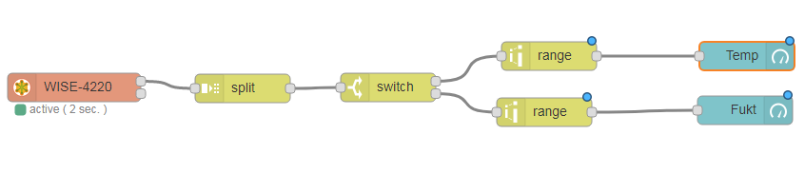
Flow:
[{"id":"683b8f41.6465c","type":"modbus-read","z":"10fab6c5.503379","name":"WISE-4220","showStatusActivities":false,"showErrors":false,"unitid":"1","dataType":"InputRegister","adr":"0","quantity":"2","rate":"2","rateUnit":"s","server":"df1a0fc2.12499","x":215,"y":360,"wires":[["aabd8217.8e16d"],[]]},{"id":"8ebaa177.995e4","type":"switch","z":"10fab6c5.503379","name":"","property":"msg.parts.index","propertyType":"msg","rules":[{"t":"eq","v":"0","vt":"str"},{"t":"eq","v":"1","vt":"str"}],"checkall":"true","outputs":2,"x":545,"y":360,"wires":[["765c6555.9d253c"],["b5474d4f.197db"]]},{"id":"aabd8217.8e16d","type":"split","z":"10fab6c5.503379","name":"","splt":"\\n","spltType":"str","arraySplt":1,"arraySpltType":"len","stream":false,"addname":"","x":392,"y":361,"wires":[["8ebaa177.995e4"]]},{"id":"3577b5e2.c7a5ba","type":"ui_gauge","z":"10fab6c5.503379","name":"","group":"614ebc4f.cc01e4","order":0,"width":0,"height":0,"gtype":"gage","title":"Temp","label":"ºC","format":"{{value | number:1}}ºC","min":"0","max":"40","colors":["#00b500","#e6e600","#ca3838"],"seg1":"","seg2":"","x":922,"y":327,"wires":[]},{"id":"cb9d923f.44b72","type":"ui_gauge","z":"10fab6c5.503379","name":"","group":"614ebc4f.cc01e4","order":0,"width":0,"height":0,"gtype":"wave","title":"Fukt","label":"%","format":"{{value | number:1}}%","min":"0","max":"100","colors":["#00b500","#e6e600","#ca3838"],"seg1":"","seg2":"","x":920,"y":384,"wires":[]},{"id":"765c6555.9d253c","type":"range","z":"10fab6c5.503379","minin":"0","maxin":"1000","minout":"0","maxout":"100","action":"scale","round":false,"name":"","x":714,"y":327,"wires":[["3577b5e2.c7a5ba"]]},{"id":"b5474d4f.197db","type":"range","z":"10fab6c5.503379","minin":"0","maxin":"1000","minout":"0","maxout":"100","action":"scale","round":false,"name":"","x":709,"y":386,"wires":[["cb9d923f.44b72"]]},{"id":"df1a0fc2.12499","type":"modbus-client","z":"","name":"WISE-4520","clienttype":"tcp","bufferCommands":true,"stateLogEnabled":false,"tcpHost":"192.168.1.2","tcpPort":"502","tcpType":"DEFAULT","serialPort":"/dev/ttyUSB","serialType":"RTU-BUFFERD","serialBaudrate":"9600","serialDatabits":"8","serialStopbits":"1","serialParity":"none","serialConnectionDelay":"100","unit_id":1,"commandDelay":1,"clientTimeout":1000,"reconnectTimeout":2000},{"id":"614ebc4f.cc01e4","type":"ui_group","z":"","name":"WISE-4220","tab":"b8820fa3.91bf5","disp":true,"width":"6"},{"id":"b8820fa3.91bf5","type":"ui_tab","z":"","name":"Trådløs sensor","icon":"dashboard"}]

REST API mot WISE-4220
Eksempel med henting av temp data fra en WISE-4220 Analog inngang med REST API kall.
Med REST kan mye mer informasjon hentes ned fra målemodul som kan gjøre ditt brukergrensesnitt mer automatisert. Navn på inngang/utgang, hvor modulen er plassert, Ferdig skalert verdi. min/max skalerings verdier + mye mer.
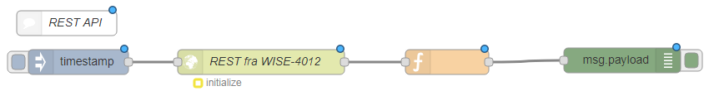
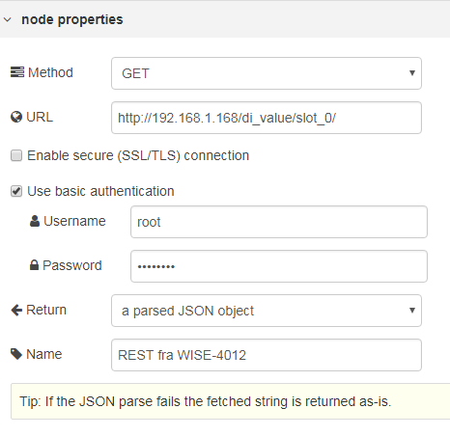

Flow:
[{"id":"d7974bd3.1a46f8","type":"inject","z":"a35c0c54.af45b","name":"","topic":"","payload":"","payloadType":"date","repeat":"","crontab":"","once":false,"x":258,"y":807,"wires":[["5a3c04c1.1ede8c"]]},{"id":"5a3c04c1.1ede8c","type":"http request","z":"a35c0c54.af45b","name":"REST fra WISE4012","method":"GET","ret":"obj","url":"http://192.168.1.168/di_value/slot_0/","tls":"","x":477,"y":807,"wires":[["7c350a66.6f0794"]]},{"id":"7c350a66.6f0794","type":"function","z":"a35c0c54.af45b","name":"","func":"msg.payload = (msg.payload.DIVal[1].Val);\nmsg.topic = 'DI0';\nreturnmsg;\n\n","outputs":1,"noerr":0,"x":700,"y":807,"wires":[["852b9c72.a2f3b"]]},{"id":"852b9c72.a2f3b","type":"debug","z":"a35c0c54.af45b","name":"","active":true,"console":"false","complete":"false","x":910,"y":805,"wires":[]},{"id":"e49aff5d.a272","type":"comment","z":"a35c0c54.af45b","name":"RESTAPI","info":"","x":244,"y":760,"wires":[]}]

Ta imot P2P data fra ADAM-6000/6200 moduler
Eksempel der P2P data taes imot i Node-Red og behandler den. Ved å benytte P2P data funksjonen i ADAM drenger man ikke å spørre om data men data blir sendt fra ADAM modulene i fastsatte intervaller.
Husk at portnr må stemme overens med konfigurasjon i ADAM modulen og i Node-Red.
ADAM-6000/6200 konfigurasjon:
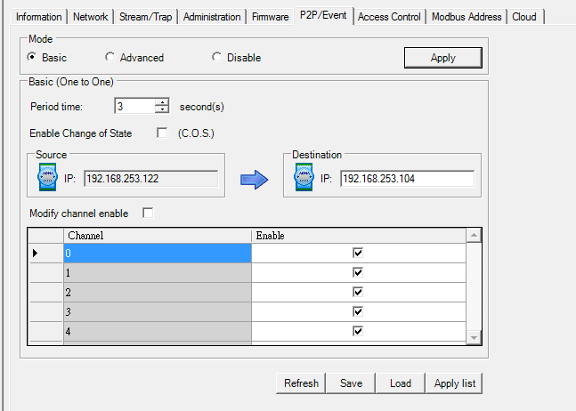
ADAM-6000/6200 konfigurasjon av P2P.
Standard UDP port er 1025
Merk: Velg alle innganger for at dette eksemplet skal fungere.
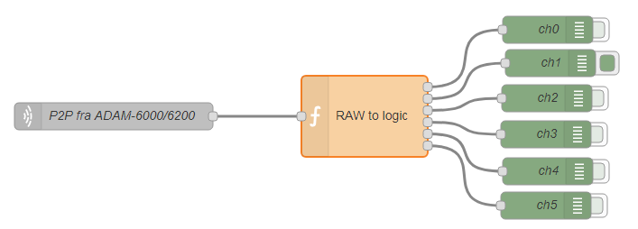
Node-Red:
Flow:
[{"id":"696747a7.ec48a8","type":"udp in","z":"77427b4.b439284","name":"Stream fra ADAM-6000/6200","iface":"","port":"1025","ipv":"udp4","multicast":"false","group":"","datatype":"buffer","x":229,"y":1009,"wires":[["b158987d.502d68"]]},{"id":"b158987d.502d68","type":"function","z":"77427b4.b439284","name":"Stream to logic","func":"var ch0, ch1, ch2, ch3, ch4, ch5;\nvar di = { payload:(msg.payload[21].toString(2)).split(\"\")};\n//Stream fra ADAM sender ikke siste inngang hvis statusen er false. Legger denne til i arrrayet manuelt\nif (di.payload.length < 6 ) {\n di.payload.unshift(\"0\");\n}\nl = { payload: di.payload.length };\n//Ender rekkeføllen på array slik at 0 = ch0\ndi.payload.reverse();\nch0 = {payload: di.payload[0]};\nch1 = {payload: di.payload[1]};\nch2 = {payload: di.payload[2]};\nch3 = {payload: di.payload[3]};\nch4 = {payload: di.payload[4]};\nch5 = {payload: di.payload[5]};\n// Verdiene som sender ut i dette eksempelet er en string. Dette må taes hensyn til i videre behandling.\nreturn [ch0, ch1, ch2, ch3, ch4, ch5];","outputs":"6","noerr":0,"x":507,"y":1009,"wires":[["6523485e.46dbf8"],["332686a.3ad1f7a"],["241a546c.e96eac"],["316c3794.6c9c48"],["bc0efbe7.9aa978"],["df46a5f0.fa4fe8"]]},{"id":"332686a.3ad1f7a","type":"debug","z":"77427b4.b439284","name":"ch1","active":true,"console":"false","complete":"payload","x":703,"y":950,"wires":[]},{"id":"6523485e.46dbf8","type":"debug","z":"77427b4.b439284","name":"ch0","active":false,"console":"false","complete":"payload","x":700,"y":913,"wires":[]},{"id":"316c3794.6c9c48","type":"debug","z":"77427b4.b439284","name":"ch3","active":false,"console":"false","complete":"payload","x":698,"y":1029,"wires":[]},{"id":"241a546c.e96eac","type":"debug","z":"77427b4.b439284","name":"ch2","active":false,"console":"false","complete":"payload","x":699,"y":989,"wires":[]},{"id":"bc0efbe7.9aa978","type":"debug","z":"77427b4.b439284","name":"ch4","active":false,"console":"false","complete":"payload","x":700,"y":1070,"wires":[]},{"id":"df46a5f0.fa4fe8","type":"debug","z":"77427b4.b439284","name":"ch5","active":false,"console":"false","complete":"payload","x":698,"y":1108,"wires":[]}]

Ta imot Stream data fra ADAM-6000/6200 moduler
Eksempel der Stream data taes imot i Node-Red og behandler den. Ved å benytte Stream data funksjonen i ADAM drenger man ikke å spørre om data men data blir sendt fra ADAM modulene i fastsatte intervaller.
Husk at portnr må stemme overens med konfigurasjon i ADAM modulen og i Node-Red.
ADAM-6000/6200 konfigurasjon:
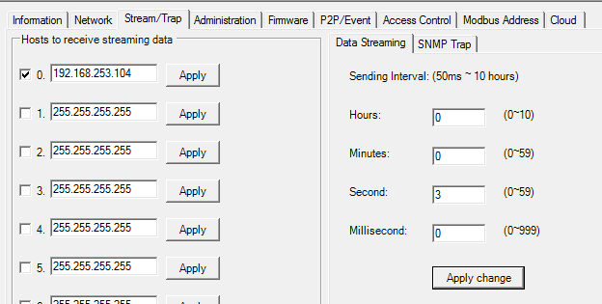
ADAM-6000/6200 konfigurasjon av Stream.
Standard UDP port er 5168
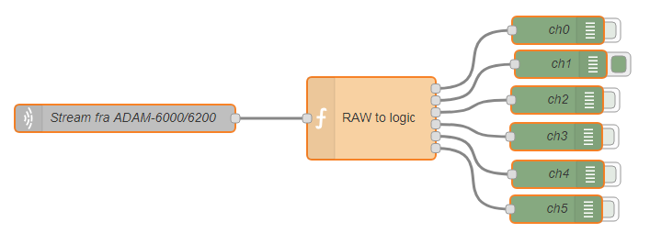
Node-Red:
Flow:
[{"id":"696747a7.ec48a8","type":"udp in","z":"77427b4.b439284","name":"P2P fra ADAM-6000/6200","iface":"","port":"5168","ipv":"udp4","multicast":"false","group":"","datatype":"buffer","x":219,"y":1009,"wires":[["b158987d.502d68"]]},{"id":"b158987d.502d68","type":"function","z":"77427b4.b439284","name":"RAW to logic","func":"var ch0, ch1, ch2, ch3, ch4, ch5;\nvar di = { payload:(msg.payload[6].toString(2)).split(\"\")};\n//Stream fra ADAM sender ikke siste inngang hvis statusen er false. Legger denne til i arrrayet manuelt\nif (di.payload.length < 6 ) {\n di.payload.unshift(\"0\");\n}\nl = { payload: di.payload.length };\n//Ender rekkeføllen på array slik at 0 = ch0\ndi.payload.reverse();\nch0 = {payload: di.payload[0]};\nch1 = {payload: di.payload[1]};\nch2 = {payload: di.payload[2]};\nch3 = {payload: di.payload[3]};\nch4 = {payload: di.payload[4]};\nch5 = {payload: di.payload[5]};\n// Verdiene som sender ut i dette eksempelet er en string. Dette må taes hensyn til i videre behandling.\nreturn [ch0, ch1, ch2, ch3, ch4, ch5];","outputs":"6","noerr":0,"x":497,"y":1009,"wires":[["6523485e.46dbf8"],["332686a.3ad1f7a"],["241a546c.e96eac"],["316c3794.6c9c48"],["bc0efbe7.9aa978"],["df46a5f0.fa4fe8"]]},{"id":"332686a.3ad1f7a","type":"debug","z":"77427b4.b439284","name":"ch1","active":true,"console":"false","complete":"payload","x":703,"y":950,"wires":[]},{"id":"6523485e.46dbf8","type":"debug","z":"77427b4.b439284","name":"ch0","active":false,"console":"false","complete":"payload","x":700,"y":913,"wires":[]},{"id":"316c3794.6c9c48","type":"debug","z":"77427b4.b439284","name":"ch3","active":false,"console":"false","complete":"payload","x":698,"y":1029,"wires":[]},{"id":"241a546c.e96eac","type":"debug","z":"77427b4.b439284","name":"ch2","active":false,"console":"false","complete":"payload","x":699,"y":989,"wires":[]},{"id":"bc0efbe7.9aa978","type":"debug","z":"77427b4.b439284","name":"ch4","active":false,"console":"false","complete":"payload","x":700,"y":1070,"wires":[]},{"id":"df46a5f0.fa4fe8","type":"debug","z":"77427b4.b439284","name":"ch5","active":false,"console":"false","complete":"payload","x":698,"y":1108,"wires":[]}]

Link opp mot WebOP Designer - WebAccessHMI
1. Overføre en True/Fals til WebOP Deisgner
2. Hente en analog verdi fra WebOP Designer som skaleres med 1 desimal.
WebOP Designer:
Gateway server settes opp og en Bit verdi og en Word verdi som linkes til 2 lokale tag-er
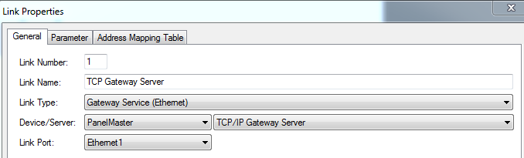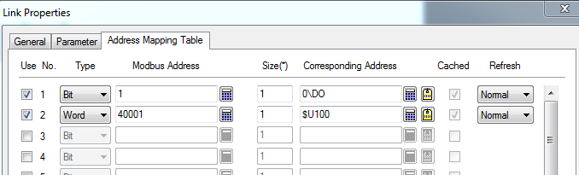
Node-Red:
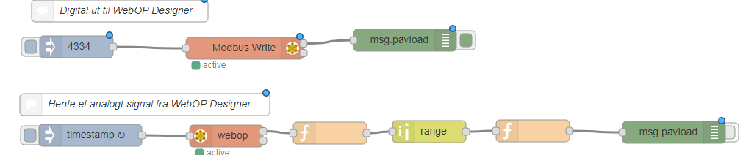
Flow:
[{"id":"a30161cc.0752","type":"modbus-write","z":"7b365178.b4bec","name":"","showStatusActivities":false,"showErrors":false,"unitid":"1","dataType":"HoldingRegister","adr":"0","quantity":"1","server":"b6687b0c.859ad8","x":537,"y":507,"wires":[["a2568925.b9a0f8"],[]]},{"id":"9ae07077.664a6","type":"inject","z":"7b365178.b4bec","name":"","topic":"","payload":"4334","payloadType":"num","repeat":"","crontab":"","once":false,"x":308,"y":505,"wires":[["a30161cc.0752"]]},{"id":"a2568925.b9a0f8","type":"debug","z":"7b365178.b4bec","name":"","active":true,"console":"false","complete":"false","x":755,"y":496,"wires":[]},{"id":"1e4ef1c6.f8a64e","type":"modbus-getter","z":"7b365178.b4bec","name":"webop","showStatusActivities":false,"showErrors":false,"unitid":"1","dataType":"HoldingRegister","adr":"0","quantity":"1","server":"b6687b0c.859ad8","x":512,"y":627,"wires":[["16d1e1a5.04c94e"],[]]},{"id":"2667debf.da1172","type":"inject","z":"7b365178.b4bec","name":"","topic":"","payload":"","payloadType":"date","repeat":"5","crontab":"","once":false,"x":327,"y":626,"wires":[["1e4ef1c6.f8a64e"]]},{"id":"ce0a7d75.f4ad1","type":"range","z":"7b365178.b4bec","minin":"0","maxin":"65535","minout":"0","maxout":"100","action":"scale","round":false,"name":"","x":788,"y":621,"wires":[["c2607b9d.ad7318"]]},{"id":"16d1e1a5.04c94e","type":"function","z":"7b365178.b4bec","name":"","func":"msg.payload = (msg.payload[0]);\nreturn msg;","outputs":1,"noerr":0,"x":653,"y":623,"wires":[["ce0a7d75.f4ad1"]]},{"id":"83eefa9c.9176b8","type":"debug","z":"7b365178.b4bec","name":"","active":false,"console":"false","complete":"payload","x":1121,"y":622,"wires":[]},{"id":"c2607b9d.ad7318","type":"function","z":"7b365178.b4bec","name":"","func":"msg.payload = (msg.payload).toFixed(1);\nreturn msg;","outputs":1,"noerr":0,"x":929,"y":620,"wires":[["83eefa9c.9176b8"]]},{"id":"b53b8cd9.e631","type":"comment","z":"7b365178.b4bec","name":"Digital ut til WebOP Designer","info":"","x":367,"y":456,"wires":[]},{"id":"bebf7ea8.23f49","type":"comment","z":"7b365178.b4bec","name":"Hente et anlogt signal fra WebOP Designer","info":"","x":391,"y":584,"wires":[]},{"id":"b6687b0c.859ad8","type":"modbus-client","z":"","name":"Webop","clienttype":"tcp","bufferCommands":true,"stateLogEnabled":false,"tcpHost":"192.168.253.100","tcpPort":"502","tcpType":"DEFAULT","serialPort":"/dev/ttyUSB","serialType":"RTU-BUFFERD","serialBaudrate":"9600","serialDatabits":"8","serialStopbits":"1","serialParity":"none","serialConnectionDelay":"100","unit_id":"1","commandDelay":"1","clientTimeout":"1000","reconnectTimeout":"2000"}]

Klokke og dato
Eksempel av enkel visning av klokke og dato.
Husk at klokke og data må setter under konfigurajon av modul. Krever restart for Node-Red skal hente korekt dato ok klokke.
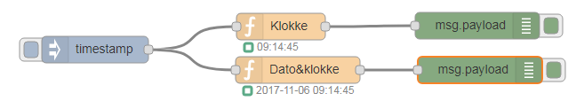
Flow:
[{"id":"2a509077.20dc9","type":"function","z":"ee92bfcd.f6fd9","name":"Klokke","func":"var d = new Date();\nvar h = d.getHours() < 10 ? \"0\"+d.getHours() : d.getHours();\nvar m = d.getMinutes() < 10 ? \"0\"+d.getMinutes() : d.getMinutes();\nvar ss= d.getSeconds() < 10 ? \"0\"+d.getSeconds() : d.getSeconds();\n//Setter status på function blokken\nnode.status({fill:\"green\",shape:\"ring\",text:\" \"+h+\":\"+m+\":\"+ss});\nmsg.payload = h+\":\"+m+\":\"+ss;\nreturn msg;\n","outputs":1,"noerr":0,"x":468,"y":369,"wires":[["135e2f1a.5aa831"]]},{"id":"1f2a2b67.c62105","type":"inject","z":"ee92bfcd.f6fd9","name":"","topic":"","payload":"","payloadType":"date","repeat":"","crontab":"","once":false,"x":259,"y":395,"wires":[["2a509077.20dc9","8af2a53b.9aacf8"]]},{"id":"135e2f1a.5aa831","type":"debug","z":"ee92bfcd.f6fd9","name":"","active":true,"console":"false","complete":"false","x":689,"y":368,"wires":[]},{"id":"8af2a53b.9aacf8","type":"function","z":"ee92bfcd.f6fd9","name":"Dato&klokke","func":"msg.timestamp= new Date().toISOString()\nvar now = new Date(); \nvar year = now.getFullYear();\nvar month = now.getMonth()+1; \nvar day = now.getDate();\nvar hour = now.getHours();\nvar minute = now.getMinutes();\nvar second = now.getSeconds(); \nif(month.toString().length == 1) {\nvar month = '0'+month;\n}\nif(day.toString().length == 1) {\nvar day = '0'+day;\n} \nif(hour.toString().length == 1) {\nvar hour = '0'+hour;\n}\nif(minute.toString().length == 1) {\nvar minute = '0'+minute;\n}\nif(second.toString().length == 1) {\nvar second = '0'+second;\n} \n//Setter status på function blokken\nnode.status({fill:\"green\",shape:\"ring\",text:\" \"+year+'-'+month+'-'+day+' '+hour+':'+minute+':'+second});\nmsg.timestamp = year+'-'+month+'-'+day+' '+hour+':'+minute+':'+second;\nmsg.payload = msg.timestamp;\nreturn msg;","outputs":1,"noerr":0,"x":487,"y":418,"wires":[["6d63476d.c2d5c8"]]},{"id":"6d63476d.c2d5c8","type":"debug","z":"ee92bfcd.f6fd9","name":"","active":true,"console":"false","complete":"false","x":692,"y":418,"wires":[]}]

Bruke dashboard template til å lage egne web objekter
node-red-dashboard pakken inneholder en rekke noder for rask og enkelt å lage ditt eget web grensesnitt med Node-Red. Hvis du trenger noe ekstra ut over det som er med så kan det la seg gjøre med template noden som følger med. Under finner du et eksempel der vi har laget et digital led lys som kan handtere true/false på inngangen.
Merk: Slike template kreves litt mer forståelse for html og javascript for.
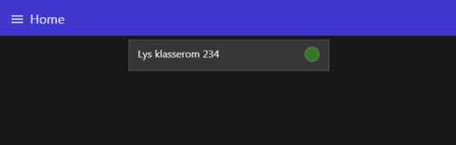
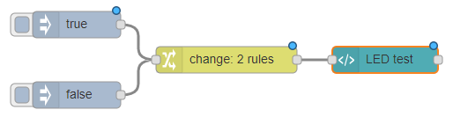
Flow:
[{"id":"e475bc59.076ca","type":"ui_template","z":"6a5354ff.12b7cc","group":"711db921.ec1598","name":"LED test","order":15,"width":"6","height":"1","format":"<style>\ndiv {\n display: flex;\n justify-content: space-between;\n margin-top: 3px;\n}\n\n.led-1 {\n width: 24px;\n height: 24px;\n background-color: darkgreen;\n border-radius: 50%;\n box-shadow: #000 0 -1px 4px 1px, inset #460 0 -1px 5px, #7D0 0 2px 9px;\n //box-shadow: #000 0 -1px 7px 1px, inset #460 0 -1px 9px, #7D0 0 2px 12px;\n} \n</style>\n\n<div>\n <p>label</p>\n <span class=\"led-1\" style=\"background-color:{{msg.payload}}\"></span>\n</div> ","storeOutMessages":true,"fwdInMessages":true,"templateScope":"local","x":680,"y":320,"wires":[[]]},{"id":"320fb814.f82528","type":"inject","z":"6a5354ff.12b7cc","name":"","topic":"","payload":"true","payloadType":"bool","repeat":"","crontab":"","once":false,"x":330,"y":280,"wires":[["a1232634.b086e8"]]},{"id":"e7326c62.a8d3c","type":"inject","z":"6a5354ff.12b7cc","name":"","topic":"","payload":"false","payloadType":"bool","repeat":"","crontab":"","once":false,"x":330,"y":360,"wires":[["a1232634.b086e8"]]},{"id":"a1232634.b086e8","type":"change","z":"6a5354ff.12b7cc","name":"","rules":[{"t":"change","p":"payload","pt":"msg","from":"true","fromt":"bool","to":"lime","tot":"str"},{"t":"change","p":"payload","pt":"msg","from":"false","fromt":"bool","to":"darkgreen","tot":"str"}],"action":"","property":"","from":"","to":"","reg":false,"x":500,"y":320,"wires":[["e475bc59.076ca"]]},{"id":"711db921.ec1598","type":"ui_group","z":"","name":"Template Eksempel","tab":"b8f27073.d4aed","disp":false,"width":"6","collapse":false},{"id":"b8f27073.d4aed","type":"ui_tab","z":"","name":"Home","icon":"home","order":1}]

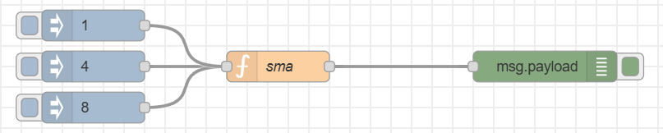
Simple Moving averages SMA
Hvis du ønsker en snitt over et vist antall målinger kan dette eksemplet brukes som et eksempel.
Eksemplet under viser snitt av de siste 10 verdiene som er registrert.
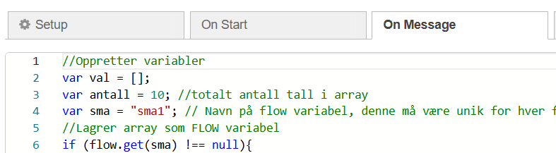

Figur 1 : Juster det totale antall målinger SMA skal
fordeles over i koden
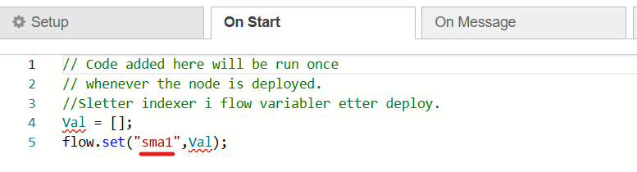
Figur 2Hvis koden skal brukes for flere verdier må variabelen være forskjellig på alle.
Den må endres under "On Start og under On Message.

Flow:
[{"id":"5c6525e1.22a59c","type":"function","z":"c5fd0d747b4b0bdd","name":"sma","func":"//Oppretter variabler\nvar val = [];\nvar antall = 10; //totalt antall tall i array \nvar sma = \"sma1\"; // Navn på flow variabel, denne må være unik for hver funksjon\n//Lagrer array som FLOW variabel\nif (flow.get(sma) !== null){\n val = flow.get(sma);\n}else{\n flow.set(sma,val); \n}\n//Leser antall i array og legger til ny verdi\nif (val.length >= antall){\n val.shift();\n}\nval.push(msg.payload);\nflow.set(sma,val);\n\n//Regner snitt av array\nvar total = 0;\nfor (var i = 0; i < val.length; i++)\n{\n total += val[i];\n}\nmsg.payload = Number((total / val.length).toFixed(1)) ; // Snitt av array med 1 desimal\nreturn msg;","outputs":1,"noerr":0,"initialize":"// Code added here will be run once\n// whenever the node is deployed.\n//Sletter indexer i flow variabler etter deploy.\nVal = [];\nflow.set(\"sma1\",Val);","finalize":"","x":430,"y":240,"wires":[["42b406cf.d92938"]]},{"id":"42b406cf.d92938","type":"debug","z":"c5fd0d747b4b0bdd","name":"","active":true,"console":false,"complete":"false","x":690,"y":240,"wires":[]},{"id":"507b129e.04027c","type":"inject","z":"c5fd0d747b4b0bdd","name":"","repeat":"","crontab":"","once":false,"topic":"","payload":"4","payloadType":"num","x":250,"y":240,"wires":[["5c6525e1.22a59c"]]},{"id":"a49ae76d.0759a8","type":"inject","z":"c5fd0d747b4b0bdd","name":"","repeat":"","crontab":"","once":false,"topic":"","payload":"8","payloadType":"num","x":250,"y":280,"wires":[["5c6525e1.22a59c"]]},{"id":"16473dc6.371d92","type":"inject","z":"c5fd0d747b4b0bdd","name":"","repeat":"","crontab":"","once":false,"topic":"","payload":"1","payloadType":"num","x":250,"y":200,"wires":[["5c6525e1.22a59c"]]}]

Kombinere innganger til en melding [objekter]
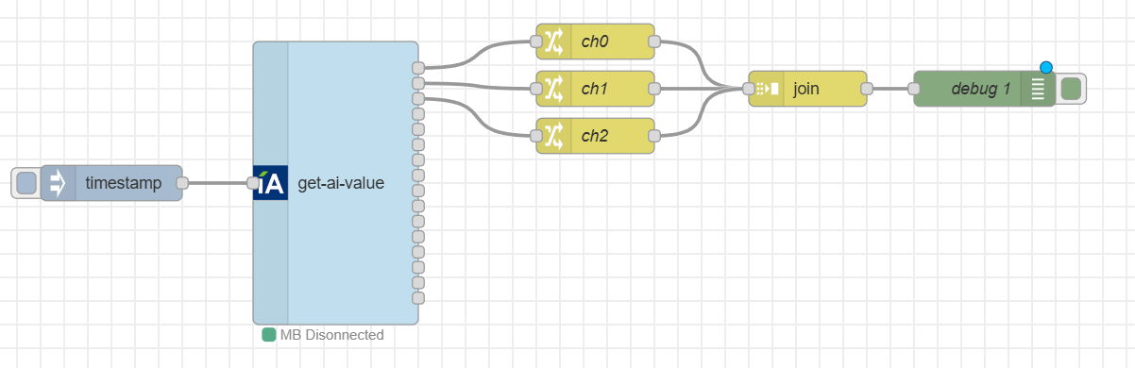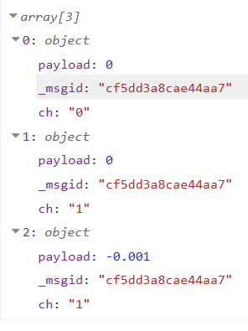
Det kan mange ganger være nødvendig å kombinere verdier for å gjøre valg eller for å sende dem videre. Dette kan du enkelt gjøre med de innebygde nodene.

Flow:
[{"id":"059d6ae795b12e11","type":"get-ai-value","z":"3042a5d53adc1ddb","name":"","x":330,"y":220,"wires":[["d07c9607316c87ef"],["7648b2f375e5f62f"],["d22fd6b7655bb5ae"],[],[],[],[],[],[],[],[],[],[],[],[],[]]},{"id":"d2cf7747ba8ffb88","type":"inject","z":"3042a5d53adc1ddb","name":"","props":[{"p":"payload"},{"p":"topic","vt":"str"}],"repeat":"","crontab":"","once":false,"onceDelay":0.1,"topic":"","payload":"","payloadType":"date","x":140,"y":220,"wires":[["059d6ae795b12e11"]]},{"id":"3a0fdda69581f9c5","type":"join","z":"3042a5d53adc1ddb","name":"","mode":"custom","build":"array","property":"","propertyType":"full","key":"ch","joiner":"\\n","joinerType":"str","accumulate":false,"timeout":"","count":"3","reduceRight":false,"reduceExp":"","reduceInit":"","reduceInitType":"","reduceFixup":"","x":730,"y":140,"wires":[["6e251b74705ae8b2"]]},{"id":"d07c9607316c87ef","type":"change","z":"3042a5d53adc1ddb","name":"ch0","rules":[{"t":"set","p":"payload","pt":"msg","to":"payload","tot":"msg"},{"t":"set","p":"ch","pt":"msg","to":"0","tot":"str"}],"action":"","property":"","from":"","to":"","reg":false,"x":550,"y":100,"wires":[["3a0fdda69581f9c5"]]},{"id":"7648b2f375e5f62f","type":"change","z":"3042a5d53adc1ddb","name":"ch1","rules":[{"t":"set","p":"payload","pt":"msg","to":"payload","tot":"msg"},{"t":"set","p":"ch","pt":"msg","to":"1","tot":"str"}],"action":"","property":"","from":"","to":"","reg":false,"x":550,"y":140,"wires":[["3a0fdda69581f9c5"]]},{"id":"d22fd6b7655bb5ae","type":"change","z":"3042a5d53adc1ddb","name":"ch2","rules":[{"t":"set","p":"payload","pt":"msg","to":"payload","tot":"msg"},{"t":"set","p":"ch","pt":"msg","to":"1","tot":"str"}],"action":"","property":"","from":"","to":"","reg":false,"x":550,"y":180,"wires":[["3a0fdda69581f9c5"]]},{"id":"ac51e6ef4505cbe8","type":"comment","z":"3042a5d53adc1ddb","name":"Kombinere innganger til en melding [objekter]","info":"","x":430,"y":40,"wires":[]},{"id":"6e251b74705ae8b2","type":"debug","z":"3042a5d53adc1ddb","name":"debug 1","active":true,"tosidebar":true,"console":false,"tostatus":false,"complete":"false","statusVal":"","statusType":"auto","x":880,"y":140,"wires":[]}]

