I dette eksemplet tar vi for oss kun de Analoge inngangene på ADAM-6717, men samme prinsippet gjelder for de andre modulene i serien.

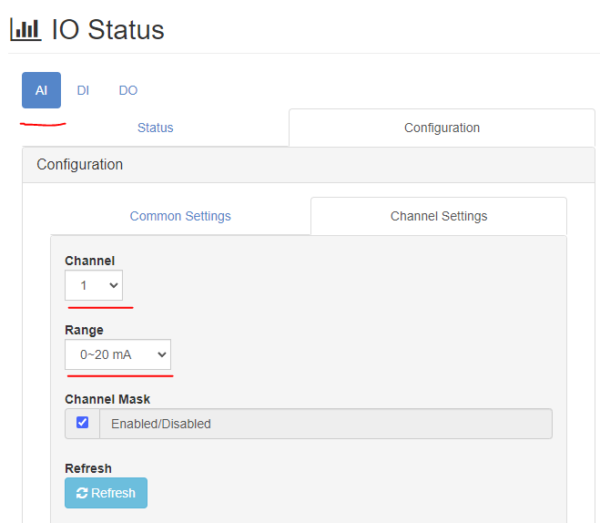
Port nr til intern Modbus server er satt som standard til 5020
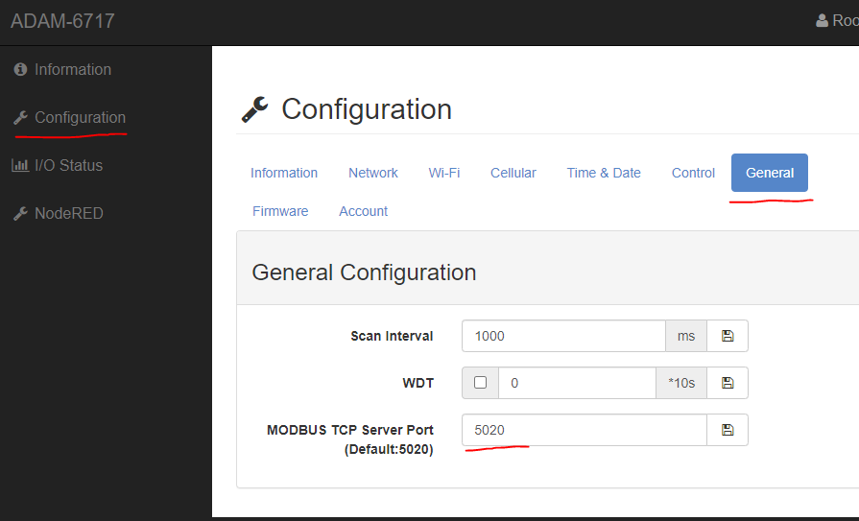

DI og DI
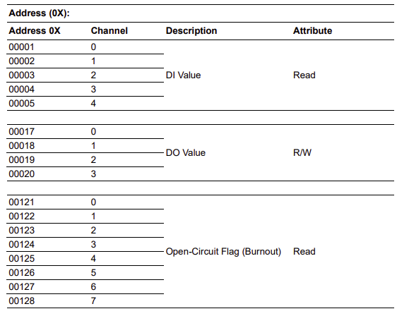
AI
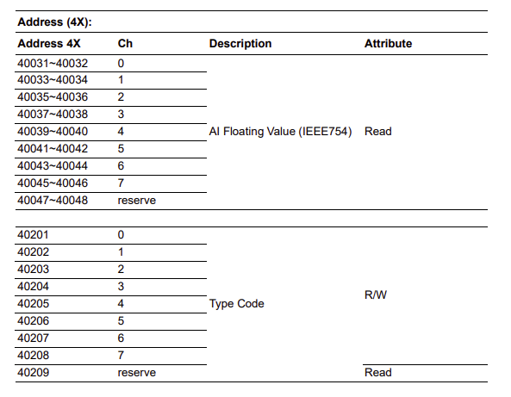
Mulig feil i manual for Type Code adresser (Starter 40200)
Code types
4-20 mA - 7
+-10V - 8
+-5V - 9
+-1V - 10
+- 500mV - 11
+-150mV - 12
+-20mA - 13
0-10V - 72
0-5V - 73
0-1V - 74
0-500mV - 75
0-150mV - 76
0-20mA - 77
Node-Red test flow
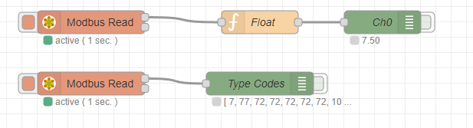
[{"id":"b46992ba.fb18b","type":"modbus-read","z":"b59af775.fce828","name":"","topic":"","showStatusActivities":false,"logIOActivities":false,"showErrors":false,"unitid":"","dataType":"HoldingRegister","adr":"31","quantity":"16","rate":"1","rateUnit":"s","delayOnStart":false,"startDelayTime":"","server":"5f555d57.61c0f4","useIOFile":false,"ioFile":"","useIOForPayload":false,"emptyMsgOnFail":false,"x":370,"y":280,"wires":[["b708076d.273f68","75d986bc.fad268"],[]]},{"id":"75d986bc.fad268","type":"function","z":"b59af775.fce828","name":"Float","func":"var buffer = new ArrayBuffer(4);\nvar view = new DataView(buffer);\nview.setInt16(0, msg.payload[1], true);\nview.setInt16(2, msg.payload[0], true);\nmsg.payload = (view.getFloat32(0, true)).toFixed(2);\nreturn msg; \n","outputs":1,"noerr":0,"initialize":"","finalize":"","x":590,"y":280,"wires":[["121fb620.68530a"]]},{"id":"121fb620.68530a","type":"debug","z":"b59af775.fce828","name":"Ch0","active":false,"tosidebar":true,"console":false,"tostatus":true,"complete":"payload","targetType":"msg","statusVal":"payload","statusType":"auto","x":750,"y":280,"wires":[]},{"id":"2c908ce0.912054","type":"modbus-read","z":"b59af775.fce828","name":"","topic":"","showStatusActivities":false,"logIOActivities":false,"showErrors":false,"unitid":"","dataType":"HoldingRegister","adr":"200","quantity":"8","rate":"1","rateUnit":"s","delayOnStart":false,"startDelayTime":"","server":"5f555d57.61c0f4","useIOFile":false,"ioFile":"","useIOForPayload":false,"emptyMsgOnFail":false,"x":370,"y":360,"wires":[["1bdb4827.873c28"],[]]},{"id":"1bdb4827.873c28","type":"debug","z":"b59af775.fce828","name":"Type Codes","active":false,"tosidebar":true,"console":false,"tostatus":true,"complete":"payload","targetType":"msg","statusVal":"payload","statusType":"auto","x":590,"y":360,"wires":[]},{"id":"5f555d57.61c0f4","type":"modbus-client","name":"","clienttype":"tcp","bufferCommands":true,"stateLogEnabled":false,"queueLogEnabled":false,"tcpHost":"127.0.0.1","tcpPort":"5020","tcpType":"DEFAULT","serialPort":"/dev/ttyUSB","serialType":"RTU-BUFFERD","serialBaudrate":"9600","serialDatabits":"8","serialStopbits":"1","serialParity":"none","serialConnectionDelay":"100","unit_id":"1","commandDelay":"1","clientTimeout":"1000","reconnectOnTimeout":true,"reconnectTimeout":"2000","parallelUnitIdsAllowed":true}]

